Major Project Report
On
VOICE-ASSISTED GRAPHIC MACHINE
By
Chirag (20622008)
Ajay kumar (20622004)
Yogendra katuwal (10621618)

Under the Guidance of
Dr. CARYNTHIA KHARKONGOR



2024-2025

Delhi Skill and Entrepreneurship University
DSEU Rajokri Campus, Rajokri
Delhi-110038
DECLARATION

I hereby declare that the project titled “VOICE-ASSISTED GRAPHIC MACHINE” submitted by our team in VIth semester of Diploma in computer engineering DSEU Rajokri Campus, comprises my own work and due acknowledgement has been made in text to all other material used.

Signature of Student:
Name:
Date:
ACKNOWLEDGEMENT

I would like to extend my heartfelt gratitude to the teachers and organizations whose support and expertise have been helpful in the successful completion of this project.

Firstly, I express my sincere appreciation to Dr. CARYNTHIA KHARKONGOR for their precious guidance, encouragement, and technical insights throughout the duration of this project. Their mentorship and expertise significantly contributed to the development of this project.

I am deeply thankful to Sh.Virender Dagar sir for their continuous guidance, encouragement, and valuable feedback I extend my appreciation to the DSEU Rajokri for providing support for the execution of this project.
ABSTRACT

This report shows the design, development, and implementation of a computer-controlled drawing and writing machine. This machine uses an Arduino Uno microcontroller along with a CNC shield to control stepper motors and a servo motor. By using Inkscape software for design creation and GRBL firmware for machine control. This project aims to create a machine which can generate any type of drawing by converting digital input from the software to physical drawings and has ability to draw with voice control. This project focus on the limitations of drawing and writing methods by offering increased speed, accuracy, and precision. The machine is able of drawing lines, shapes, and text with high precision, making it easy to perform several tasks.
The Voice-Assisted Graphic Machine represents a significant advancement in the field of computer-controlled drawing and writing machine. By combining advanced technology with innovative features such as voice control, this project offers a convincing solution to the limitations of traditional methods with its focus on speed, accuracy, and precision.

 | TABLE OF CONTENTS
S NO. | TITLE | PAGE NO.
1 | Introduction………………………………………. | 1
 | 1.1 Project Background…………………………...
 | 1.2 Existing Systems……………………………... | 2
 | 1.3 Proposed System……………………………...
 | 1.4 Aim and Objectives…………….…………….. | 3
 | 1.4 Benefits……………………………………….. | 4
2 | Project Planning………………………………….. | 6
 | 2.1 Project Schedule………………………………
 | 2.2 Gantt Chart/Timeline Chart ………………….. | 7
 | 2.3 Work Breakdown Structure ………………….. | 8
 | 2.4 Hardware and Software Resource Requirements | 9
3 | Analysis…………………………………………... | 14
 | 3.1 Business Needs……………………………..…
 | 3.2 Functional and Non-functional Requirements…
 | 3.3 Constraints……………………………………. | 15
 | 3.4 Feasibility Study………………………………
 | 3.5 Use Case Analysis……………………………… | 16
4 | System Design……………………………………. | 17
 | 4.1 System Architecture…………………………..
 | 4.2 Flow Chart…………………………………… | 18
 | 4.3 Physical Design………………………………. | 19
5 | System Implementation………………………….. | 20
 | 5.1 Module Details and Abstraction………………
 | 5.2 Source Code…………………………………..
 | 5.3 Snapshots…………………………………….. | 22
6 | Conclusion and Future Scope……………………. | 24
 | 6.1 Observations of Outputs……………………….
 | 6.2 Limitations…………………………………… | 25
7 | Future Scope………………………………….. | 26
8 | Reference…………………………………………. | 27

 | LIST OF FIGURES & TABLES
No. | TITLE | PAGE NO.
Table 1. | Gantt chart…………………………………. | 7
Figure 1. | Arduino uno……………………………….. | 9
Figure 2. | CNC Shield………………………………... | 9
Figure 3. | Stepper Motor……………………………… | 10
Figure 4. | A988 Stepper Motor Driver……………….. | 10
Figure 5. | Servo Motor………………………………. | 11
Figure 6. | Jumper Wires……………………………… | 11
Figure 7. | Iron Slider………………………………… | 12
Figure 8. | Belt & Pulley……………………………… | 12
Figure 9. | System architecture of project…………….. | 17
Figure 10. | Flowchart of project……………………….. | 18
Figure 11. | Physical Design of project………………… | 19
Figure 12. | First Snap of Code………………………… | 20
Figure 13. | Second Snap of Code……………………… | 21
Figure 14. | Third Snap of Code……………………….. | 21
Figure 15. | Forth Snap of Code……………………….. | 22
Figure 16. | Top view of the project……………………. | 22
Figure 17. | Front view of the project………………….. | 23
Figure 18. | Side view of the project…………………… | 23

- INTRODUCTION
1

  - Project Background
In the zone of traditional art creation, the process often demands considerable effort and artistic good, presenting inherent challenges. Manual drawing and writing, while deeply fixed in artistic expression, are not without their limitations. These methods can be time-consuming, prone to errors, and may lack the precision and accuracy desired in the final output. Recognizing these obstacles, the Voice-Assisted Graphic Machine occurs as a transformative solution, linking the gap between traditional artistry and modern automation [2]. At its core, the Drawing and Writing machine project expresses a commitment to innovation and efficiency. By leveraging advanced technology, this project aims to develop the way artworks are produced. The integration of voice assistance introduces a new dimension of interaction, enabling users to give the commands and directives easily. This interface built for modernizes the creative process, eliminating the need for labour- thorough manual input.

Central to the project's objectives is the concept of automation. Through particular design and engineering, the Voice-Assisted Graphic Machine offers a all-in-one system, minimizing the difficulties associated with traditional art creation [2]. By assigning the power of automation, artists and creators can crack new levels of productivity and precision, transcending the limitations of manual techniques. Furthermore, the project addresses the inherent challenges of accuracy and precision. In contrast to manual methods, which are vulnerable to human error, the Drawing and Writing machine project prioritizes precision and consistency. By employing cutting-edge technologies. The system ensures that artworks are executed with unmatched accuracy, meeting the highest standards of quality.

Beyond efficiency and accuracy, the Voice-Assisted Graphic Machine represents a vision of accessibility. This project allows individuals of all skill levels to set free their creativity [2]. Whether a user is beginner or professional, users can connect easily the capabilities of the machine to bring their visions to life with comfort. The project's emphasis on efficiency is highlighted by its ability to generate artworks in a section of the time required by traditional methods. By automating repetitive tasks and optimizing plan processes, the Voice-Assisted Graphic Machine enables users to produce high-quality artworks within compressed time. This not only enhances productivity but also opens up new possibilities for experimentation.

The Drawing and Writing machine project represent an original aim in the zone of art and technology. By combining the principles of automation with the open power of traditional artistry, this project redefines the boundaries of creativity. Through its commitment to efficiency, accuracy, and accessibility, the Voice-Assisted Graphic Machine heralds a new era of innovation, empowering artists to realize their visions with unprecedented ease and precision [3].
  - Existing System
2
The existing systems in the domain of art and graphic creation include a variety of solutions, each targeting to address the challenges associated with manual processes. Among these existing systems: -
- Industrial printing machines: -
Industrial printing machines represent a projecting solution for large-scale graphic production. These machines are capable of producing high-quality prints on various materials, ranging from paper to cloth and elsewhere. While industrial printing machines shine in build production and consistency, they often require specialized expertise to operate and may not be easily accessible to individual artists or small-scale creators.

- Typewriter: -
Typewriters, although considered a trace of the past, still hold significance in certain circumstances. These mechanical devices are well-known for their simplicity and reliability in creating typed text. While typewriters offer a tangible experience, their functionality is limited primarily to text-based output, making them less suitable for difficult graphic designs or complex artistic expressions.

- Logo design: -
In a digital graphic design, logo design software plays a fundamental role in creating visual identities for businesses and organizations. These software tools offer a wide range of features and functionalities, allowing users to manipulate shapes, colours, and design to craft unique logos and branding materials. However, while logo design software provides flexibility and creativity in graphic design, it often requires a learning arc and may not provide specifically to the needs of traditional artists or those seeking hands-on creative expression.

In contrast to these existing systems, the Voice-Assisted Graphic Machine represents a transformative rise forward in art and graphic creation [2]. By integrating advanced technology with voice assistance, this advanced system modernizes the creative process, offering unique efficiency and precision. Unlike industrial printing machines, the Voice-Assisted Graphic Machine is designed for individual artists and creators, allowing them to understand their artistic visions with easily. Furthermore, it rise above the limitations of typewriters and logo design software by offering a wide-ranging solution for both drawing and writing tasks.

  - Proposed System
The proposed system of the Voice-Assisted Graphic Machine introduces a multipurpose drawing and writing machine designed to mimic human-like abilities [2]. This innovative system is prepared to perform tasks traditionally associated with artistic expression, such as creating artwork and writing, with outstanding precision and efficiency. This project proposes a drawing and writing machine that capable for the performing task like drawing artwork, writing like a human being with the use of software like Inkscape which converts the digital to physical output.
3
Utilizing sophisticated software like Inkscape, the machine like a dream translates digital designs into physical outputs, connecting the gap between digital creativity and physical artworks. This combination of software not only enhances the machine's flexibility but also ensures that the final output meets the highest standards of quality. Moreover, the system's voice-assisted capabilities add a layer of interactivity and easy to use. Users can simply give commands to the machine, eliminating the need for complex manual input and streamlining the creative process. The proposed system of the Voice-Assisted Graphic Machine represents a significant advancement in the area of art and technology. By combining the precision of automation with the expressive power of human-like artistry, this system offers a transformative solution for artists and creators looking for to release their creativity with incomparable ease and precision [3].

  - Aim and Objectives
The aim of the Voice-Assisted Graphic Machine project is to create a computer-controlled drawing and writing machine that controls technology to modernize the art-making process. This main goal is supported by several specific objectives that outline the key steps needed to achieve it. This project is to design, develop, and implement a computer-controlled drawing and writing machine. The Voice-Assisted Graphic Machine project sets out to develop the art-making process by combining advanced technology with traditional technique. Through its aim and objectives, the project seeks to create a versatile and user-friendly machine capable of producing high-quality artwork with precision and efficiency. By addressing key challenges innovative solutions, the project aims to allow artists of all skill levels to set free their creativity with unique ease and accuracy. This aim is further broken down into specific objectives:
- To generate an algorithm that process the machine for how to work: -
The project aims to develop an algorithm that serves as the brain of the machine, guiding its operations and enabling it to interpret commands effectively. This algorithm is crucial for ensuring that the machine can understand and execute user instructions accurately.

- Converts digital input from the software to physical output: -
The project search for to link the gap between digital input and physical output by creating a mechanism that translates digital designs into physical artwork on paper. This involves developing a system capable of precise movements and adjustments to copy the digital designs with accuracy.

- To construct a machine with available components like Arduino Uno, CNC shield, stepper motors, and a servo motor: -
In terms of construction, the project aims to build the machine using available components such as the Arduino Uno microcontroller, CNC shield, stepper motors, and a servo motor. By utilizing these components, the project ensures accessibility and affordability while maintaining functionality and performance.
4
- Generating code to draw the artwork through the voice command: -
It is to develop code that controls the machine's movements and actions in response through the voice commands. This feature not only enhances user experience but also adds a layer of interactivity and convenience to the art-making process.

- Controls the motors to move the iron rods: -
The project aims to implement mechanisms for controlling the motors in multiple directions using iron rods. This capability is essential for achieving difficult and detailed artwork while maintaining constancy and precision.

- GRBL firmware for machine control: -
Finally, the project aims to integrate Inkscape software for design creation and GRBL firmware for machine control. By leveraging existing software solutions, the project can take advantage of on traditional tools and frameworks, reducing development time and complexity [3].

  - Benefits
The Voice-Assisted Graphic Machine introduces benefits that significantly better than traditional methods of art creation [2]. The Machine offers benefits that redefine the landscape of art creation. From its voice control interface to its unmatched speed, precision, and educational potential, the machine represents a example modification in how artworks are produced and experienced. By joining the power of automation and technology, it allows artists and educators the same to push the limits of creativity and knowledge achievement, ultimately inspiring the artistic. Let's explore into each of these advantages in details:
- Voice controlled:
You can perform task by the voice command. This feature develops the way tasks are executed on the machine. By simply using voice commands, users can direct through various functions easily. This not only eliminates the need for manual input but also enhances accessibility, especially for individuals with limited flexibility or skill challenges. With voice control, the machine becomes a user-friendly tool for artists of all skill levels. [2].

- Increased Speed and Efficiency:
The machine can automate drawing and writing tasks that reduce the time required to complete compare to the manual methods. One of the benefits of the Voice-Assisted Graphic Machine is its ability to automate drawing and writing tasks, leading to a important increase in speed and efficiency. This efficiency not only saves valuable time but also allows artists to focus more on the creative aspect of their work rather than the technical execution.

- Enhanced Accuracy and Precision: By using computer-controlled motors, the machine can achieve higher precision in lines, curves, and text compared to manual drawing. The machine achieves incomparable levels of accuracy and precision in its output. Unlike manual drawing, where imperfections and inconsistencies are unavoidable, the machine's precise movements ensure that lines, curves, and text are rendered with highest accuracy. This level of precision not only enhances the quality of the final artwork but also opens up new opportunities for difficult designs and complex compositions.
5

- Educational Applications: The machine can be a valuable tool in educational field. It can help students to understand the concepts of practice drawing techniques and the working principle of the machine. The Voice-Assisted Graphic Machine serves as a valuable educational tool [2]. In educational backgrounds, it can play a fundamental role in teaching students various drawing techniques and principles. By providing hands-on experience with the machine, students can gain a deeper understanding of concepts such as line weight, shading, and perspective. The machine's ability to visualize the drawing process in real-time facilitates interactive learning experiences, making it an invaluable asset in art.
- PROJECT PLANNING
6

  - Project Schedule
This project schedule provides a structured framework for the efficient development of the Voice-Assisted Graphic Machine, ensuring that each phase is executed in a timely manner and contributing to the successful understanding of the project objectives. This project utilizes a three-month timeline divided into phases with durations:
Week 1-3:
- Research, Design, and Component Selection (Focus on researching existing solutions, defining system requirements, and selecting hardware and software components) - During these initial three weeks, the focus is on gathering information, defining project requirements, and selecting the necessary hardware and software components. This involves researching existing solutions in the field, understanding the functionalities required for the Voice-Assisted Graphic Machine, and making informed decisions about the components to be used.

Week 4-5:
- Machine Construction and Assembly (Assemble the mechanical structure using frame, motors, and pen holder) - With the components selected, the next phase involves physically constructing the machine. This includes assembling the mechanical structure, which typically comprises the frame, motors, and pen holder. The goal is to create a strong and functional framework that will support the operations of the Voice-Assisted Graphic Machine.

Week 6-8:
- Software Development and Integration (Develop Arduino code for motor control and integrate GRBL firmware) - Once the machine's physical structure is in place, attention shifts to the development and integration of software components. This involves writing code for motor control, ensuring smooth and precise movement of the components. Additionally, integration with GRBL firmware, a common firmware used for CNC machines, is assumed to facilitate communication between hardware and software.
Week 9:
- Testing (Test machine functionality, checkup motor movements, and refine control parameters) - As the project nears completion, the focus turns to testing and validation. This involves assessing the functionality of the Voice-Assisted Graphic Machine, ensuring that motor movements are accurate and responsive. Any issues or discrepancies are identified and addressed during this phase, ensuring that the machine operates as planned.
Week 10:
7
- Documentation and Refinement - In the final week, efforts are directed towards documenting the project and making refinements based on testing feedback. This includes finalizing the project report, documenting lessons learned throughout the process, and identifying areas for potential improvement. By systematically documenting the project's development and outcomes, valuable insights are captured for future reference.

  - Gantt Chart (or Timeline Chart)

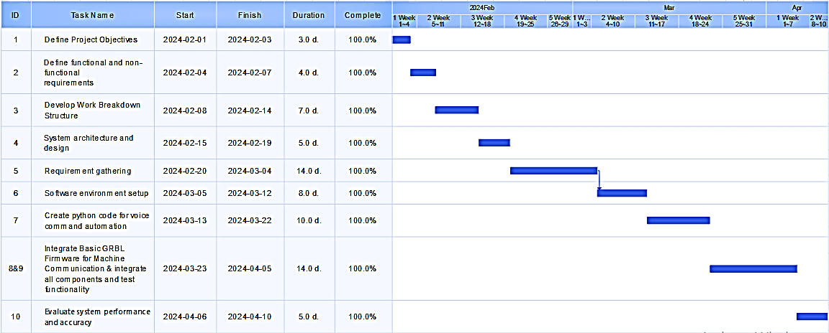
Table 1. The table chart will show the duration of each task performed throughout the project.

  - Work Breakdown Structure (WBS)
8

- Project Management
- Develop Project Schedule - This involves creating a timeline for the project, outlining key milestones and deadlines.
- Identify Resources - Identifying the necessary resources such as personnel, equipment, and materials needed for the project.
- Track Progress and Budget - Monitoring the project's progress and expenses to ensure it stays on track and within budget.

- Hardware Development
- Select Components (motors, frame materials) - Choosing the appropriate motors and materials for the frame that will best suit the requirements of the machine.
- Design and Build Mechanical Structure - Creating the physical structure of the machine, including the frame and any moving parts.
- Integrate Motors and Pen Holder - Incorporating the selected motors into the mechanical structure and designing a mechanism to hold the pen or drawing tool.

- Software Development
- Develop Arduino Code for Motor Control - Writing code for the Arduino microcontroller to control the movement of the motors.
- Integrate GRBL Firmware for Machine Communication - Integrating the GRBL (G-code sender) firmware to facilitate communication between the software and the machine [3].
- Design User Interface for Control Software - Creating a user-friendly interface for controlling the machine, which may involve developing software for computer or mobile device interaction.

- Testing and Evaluation
- Conduct Functional Testing of Machine Movements - Testing the machine's movement capabilities to ensure it functions as intended.
- Calibrate Motor Steps and Accuracy - Fine-tuning the motor control settings to achieve the desired precision and accuracy in the machine's movements.
- Evaluate Overall Performance (speed, precision) - Assessing the machine's overall performance in terms of speed, accuracy, and efficiency.

- Documentation and Reporting
- Prepare Project Report - Compiling all relevant information about the project, including its objectives, methodologies, results, and conclusions.
- Document Design Choices and Code - Documenting the design decisions made throughout the project and providing detailed documentation of the software code developed.
- Present Findings and Recommendations - Communicating the findings of the project through presentations or reports and making recommendations for future improvements or developments.
  - Hardware and Software Resource Requirements
9
Hardware: These hardware components form the foundation of the Voice-Assisted Graphic Machine, enabling it to automate the process of creating artworks with precision and efficiency. Each component is carefully selected and integrated into the system to ensure smooth operation and reliable performance. The hardware components listed are integral parts of machine, each playing a specific role in its functionality:
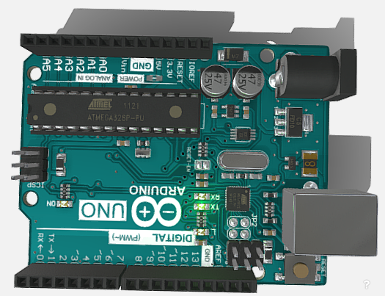
- Arduino uno: Microcontroller to control all operations. Arduino UNO is a microcontroller board based on the ATmega328P. It has 14 digital input/output pins (of which 6 can be used as PWM outputs), 6 analog inputs, a 16 MHz ceramic resonator, a USB connection, a power jack, an ICSP header and a reset button. It contains everything needed to support the microcontroller [8].
Fig. 1 Arduino uno

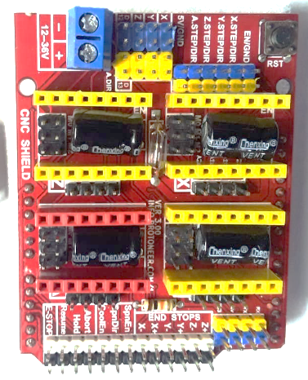
- CNC Shield: CNC shield V3 is an open-source hardware used to control stepper motors. Allows to control 4 motors simultaneously. It uses removable A4988 stepper controls. Stepper motors are connected via 4-pin connectors. Its supply voltage is 12-36 V [9][1].

Fig. 2 CNC Shield

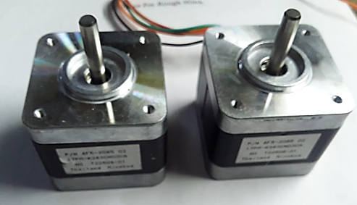
- Stepper motor: It is an electrical motor that rotates in a series of small angular steps, instead of continuously. Stepper motors are a type of digital actuator. It converts electrical energy to mechanical energy [10].
10
Fig. 3 Stepper Motor

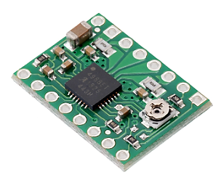
- A4988 stepper motor driver: This breakout board for Allegro’s A4988 microstepping bipolar stepper motor driver features adjustable current limiting, over-current and over-temperature protection, and five different microstep resolutions (down to 1/16-step). It operates from 8 V to 35 V [12].
Fig. 4 A988 Stepper Motor Driver
- Servo motor: Servo motor is a type of motor that can rotate with great precision. It can rotate any specific angle and gives feedback of its current position [11].
11
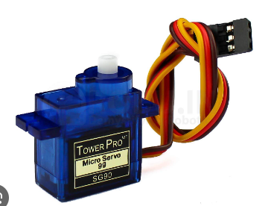
Fig. 5 Servo Motor

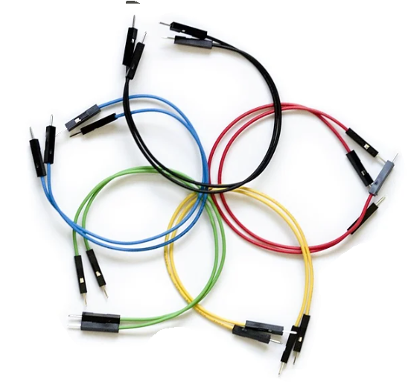
- Jumper wires: Jumper wires are simply wires that have connector pins at each end, allowing them to be used to connect two points to each other without soldering. Jumper wires are typically used with breadboards [13].
Fig. 6 Jumper wires

- 12V Battery: The battery serves as the power source for the machine, providing the necessary electrical energy to drive the motors and other components.

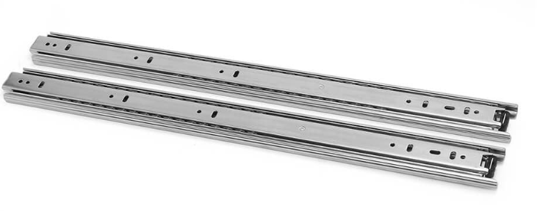
- Frame and iron rods: The frame provides structural support for the machine, while the iron rods serve as guides for the movement of the drawing mechanism along the X and Y axes.
12
Fig. 7 Iron Slider

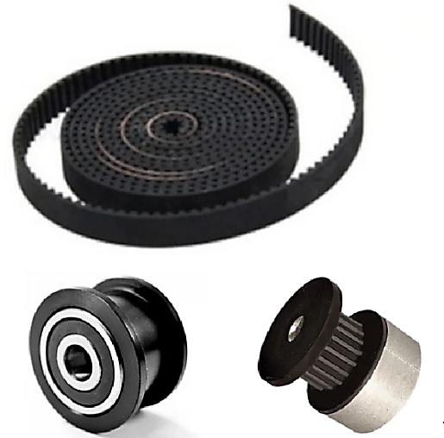
- GT2 Timing Belt, Pulley: These components are part of the mechanism that translates the rotational movement of the stepper motors into linear motion along the axes, allowing for precise control over the positioning of the drawing tool [14].
Fig. 8 Belt & Pulley

Software: The software components of the Voice-Assisted Graphic Machine play a crucial role in enabling its functionality and usability.
- Operating System Compatibility: The Voice-Assisted Graphic Machine is designed to be compatible with various operating systems, including Windows 10 or later, macOS, and Linux. This broad compatibility ensures that users can access and utilize the machine's features irrespective of their preferred operating system.

- Web Browser Support: The machine is supporting web browsers such as Google Chrome, Firefox, and Microsoft Edge. This allows users to control and interact with the machine's interface easily through familiar browser environments, enhancing user convenience and accessibility.
13

- Software Applications: Two main software applications are essential for the operation of the Voice-Assisted Graphic Machine:
  - Inkscape: Inkscape serves as a powerful vector graphics editor, enabling users to create and manipulate graphical elements with precision and flexibility. It plays a central role in designing the artwork or graphics that the machine will produce.
  - Universal G-code Sender: This software facilitates the transmission of G-code instructions to the machine [3]. G-code is a language used to control CNC (Computer Numerical Control) machines like the Voice-Assisted Graphic Machine. Universal G-code Sender ensures smooth communication between the user's computer and the machine, allowing for accurate execution of design instructions.

- Programming Language and Firmware: The Voice-Assisted Graphic Machine relies on the "GRBL firmware" for coding instructions to the microcontroller. GRBL (pronounced 'garble') is an open-source, high-performance CNC firmware that translates G-code commands into precise movements of the machine's motors [3]. It provides a standardized interface for controlling the machine's operations and ensures accuracy and reliability in executing design commands.

- Arduino Integrated Development Environment (IDE): Arduino IDE serves as the primary platform for writing, compiling, and uploading firmware code to the microcontroller of the Voice-Assisted Graphic Machine. It provides a user-friendly environment for developers to program the machine's behaviour and customize its functionality according to specific requirements.

- ANALYSIS
14

  - Business Needs
This project has several importance in business zone such as:
- Simple Design Creation for Logos on Banners
- In today's business environment, companies regularly need to create promotional materials quickly and efficiently.
- The Voice-Assisted Graphic Machine addresses this requirement by offering a basic process for designing logos and graphics to be used on banners [2].
- By enabling users to interact with the machine using voice commands, the creation process becomes more natural and available.
- This capability updates the design process, allowing businesses to produce high-quality banners with minimal effort and time savings.

- Personalized Product Creation with Custom Designs
- Customization is attractive more and important in the business world as companies try to find offer unique products personalized to individual preferences.
- The Voice-Assisted Graphic Machine facilitates personalized product creation by allowing users to easily generate custom designs [2].
- Whether it's printing personalized products or creating custom-made materials, the machine's automation and voice command features allow businesses to meet the growing demand for customization.

- Time Consumption Reduction through Automation and Voice Commands
- Time is a valuable resource in business, and efficiency is key to staying competitive.
- The Voice-Assisted Graphic Machine significantly reduces time consumption by automating repetitive tasks and enabling voice-controlled operation [2].
- By automating the design process, businesses can create artworks and graphics in a part of the time required by manual methods.
- This time-saving capability not only increases productivity but also enables businesses to meet target and respond quickly to market demands.

  - Functional and Non-Functional Requirements
The Voice-Assisted Graphic Machine's functional requirements focus on enabling user interaction, software integration, and drawing versatility, while its non-functional requirements emphasize accuracy, speed, maintainability, and cost-effectiveness. By meeting these criteria, the machine can deliver and satisfying user experience while pushing the limitations of creativity in art production. The machine should have to achieve essential functions and some desire functions.
- Functional Requirements:
15
- Accept user input for design selection or voice/text commands.
- Integrate with Inkscape design software for G-code conversion.
- Offer different drawing modes such as line, polygon and other shapes.

- Non-Functional Requirements:
- Accuracy: Contains high accuracy and precision.
- Speed: Operate at variable speeds with at maximum frame rate.
- Maintainability: Design the machine for easy maintenance and component replacement.
- Cost-effectiveness

  - Constraints
The limitations or challenges faced during the project. These could include:
- This project requires some cost to buy the hardware components.
- It takes long time and effort to complete the hardware project.
- There is difficulty to finding specific components that necessary.

  - Feasibility Study
The feasibility study aims to provide a complete understanding of whether the Voice-Assisted Graphic Machine project is technically feasible and economically feasible. By analysing the compatibility of selected components, assessing development costs, and projecting possible takings, stakeholders can make informed decisions about proceeding with the project.
Identifying the project feasibility in various area:
- Technical Feasibility:
- The first step is to analyse whether all the desired functionalities of the Voice-Assisted Graphic Machine can be implemented using the selected hardware and software components.
- This includes assessing the compatibility and integration of various technologies such as voice recognition, automation.
- The feasibility study involves examining whether these components can work together effortlessly to achieve the project objectives.

- Cost-Effectiveness Analysis:
  - Another feature of the feasibility study is evaluating the cost-effectiveness of the project.
- This involves assessing the costs related with obtaining the necessary hardware and software components.

  - Use-Case Analysis
16
Use Case 1: Drawing a Simple Design
- User imports a pre-designed image into the Inkscape software to convert it into G-code.
- User selects desired drawing speed and frame rate settings.
- Machine automatically draws the design on the drawing surface.
Use Case 2: Writing Text
- User selects the desired font style and size.
- User enters text content into the Inkscape software interface and generate G-code.
- Machine writes the text on the drawing surface with precise positioning and spacing.

- SYSTEM DESIGN
17

  - System Architecture
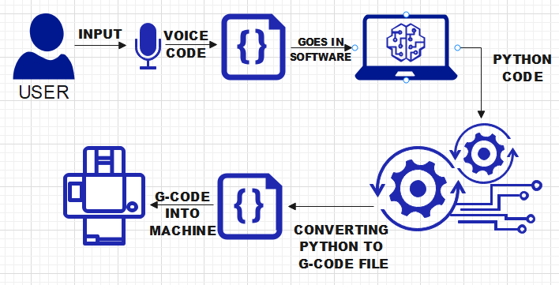
Fig. 9 System architecture of project

The above architecture is displayed to explain the system:
- Input:
- Users interact with the system by providing input through speech recognition. This interface allows for easy communication with the machine, enhancing user experience and accessibility.

- Speech Recognition:
- Utilizing Python code, the system captures and interprets user input received via voice commands [2]. This functionality serves as the gateway for users to convey their artistic purposes to the machine accurately.

- Conversion to G-code:
- Once user commands are captured, the Python code processes this input, translating it into G-code instructions. G-code serves as a standardized language for controlling automated machinery, enabling precise control over the movement of the drawing implement [4].

- Arduino Uno Microcontroller:
- Acting as the central control unit, the Arduino Uno microcontroller receives the processed commands and rewrites the operation of the machine's components [5].
18

- Motor Control and Pen Movement:
- The Arduino Uno interfaces with motors responsible for driving the pen mechanism across the designated drawing surface [12]. By translating G-code instructions into physical movements, the motors execute precise paths, bringing the user's artistic vision to life with accuracy.

- Output:
- As a result of coordinated motor control, the output displays as the desired design or text reduced on the drawing surface. The corresponding motion of the pen, guided by the G-code instructions, faithfully reproduces the user's creative intent.

  - 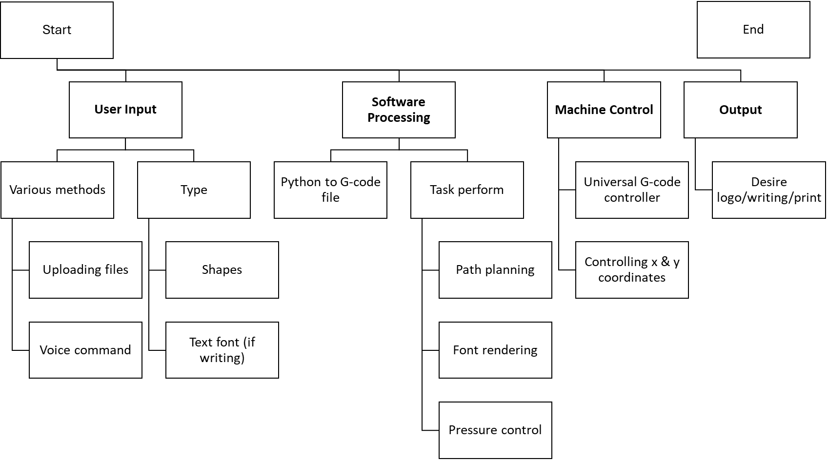Flowchart

Fig. 10 Flowchart of project

  - Physical Design
19
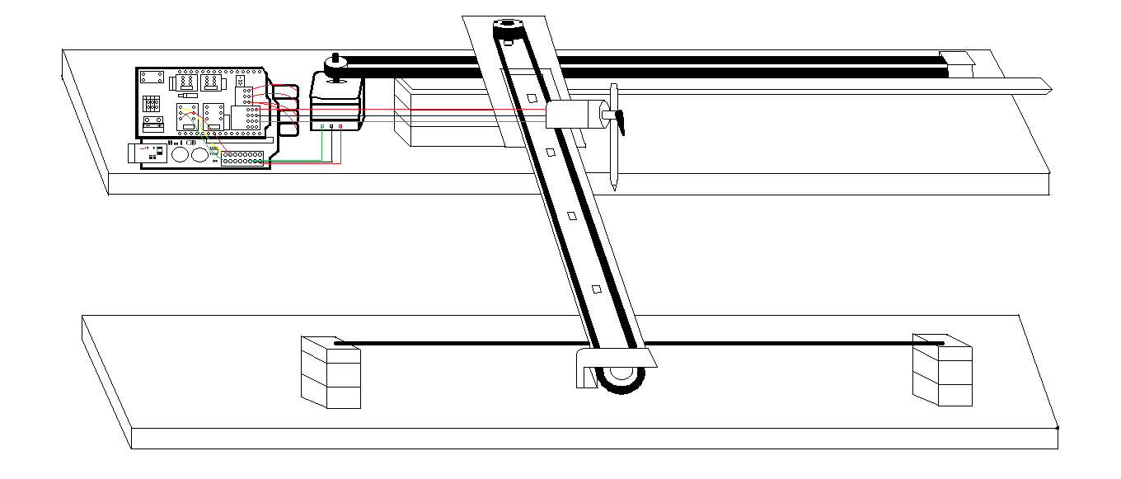
Fig. 11 Physical Design of project

The physical structure of the machine, including details like:
- Frame Material: Selection of material for the machine's base for stability.
- CNC Shield: CNC shield V3 is an open-source hardware used to control stepper motors. Allows to control 4 motors simultaneously [1].
- Motor Placement: Explain how the stepper motors are positioned and secured to achieve desired movement range [7].
- Pen Holder Design: Describe the mechanism for holding the drawing pen and ensuring smooth movement across the surface [6].
- The connection between the all the hardware.

- SYTEM IMPLEMENTATION
20

  - Modules and Abstraction
The system modules connection at different stages:
- Motor Control Module: Handles communication with the Arduino and controls stepper motor movements based on received commands [5].
- CNC Sheild: It handles the communication machine and Arduino for voltage supply [1].
- Communication Module: Helps in communication between the Universal G-code software and the Arduino Uno via a serial connection [4].

  - Source Code
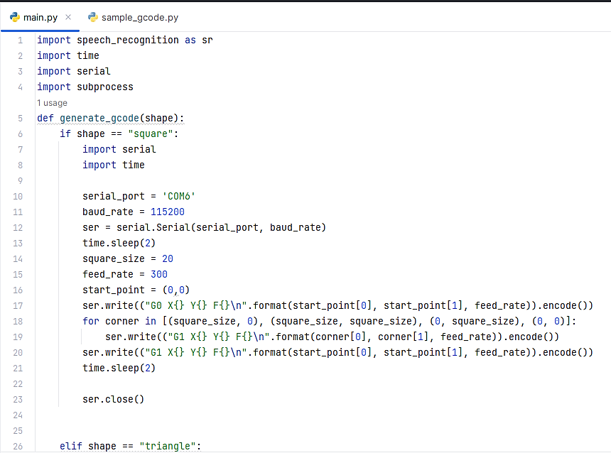
https://github.com/ItsDeveloperChirag/Voice-Control-2D-Printer
Fig. 12 First Snap of Code
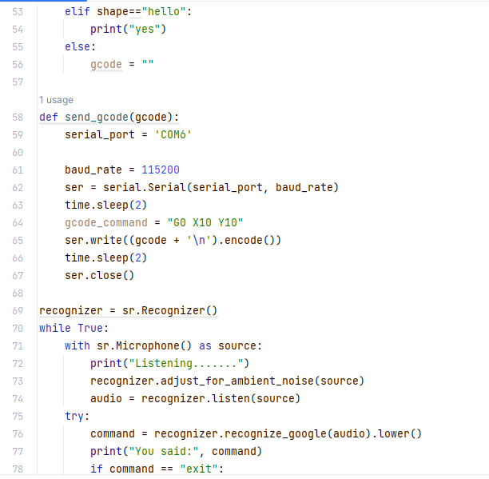
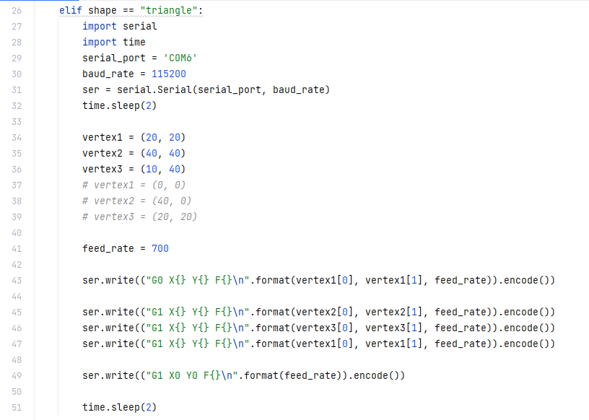
21
Fig. 14 Third Snap of Code
Fig. 13 Second Snap of Code
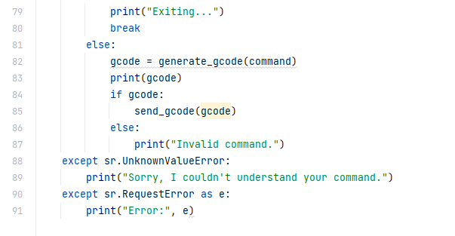
22
Fig. 15 Forth Snap of Code

  - Snapshots of Project
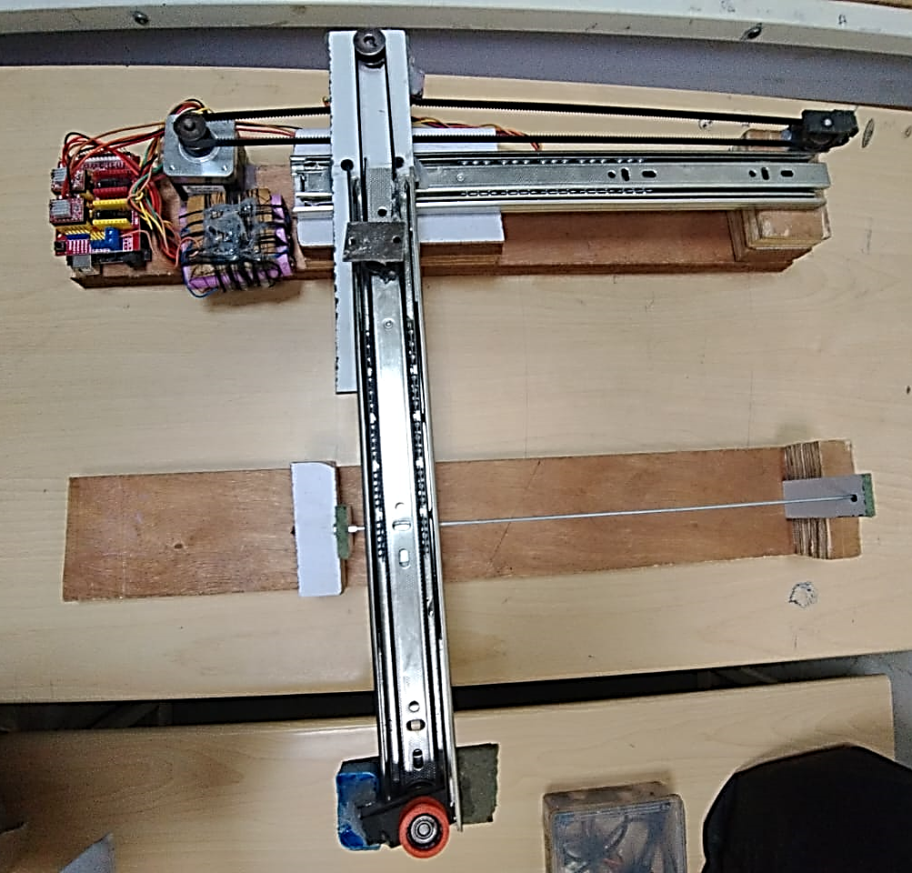
Fig. 13 Front view of the project
Fig. 16 Top view of the project

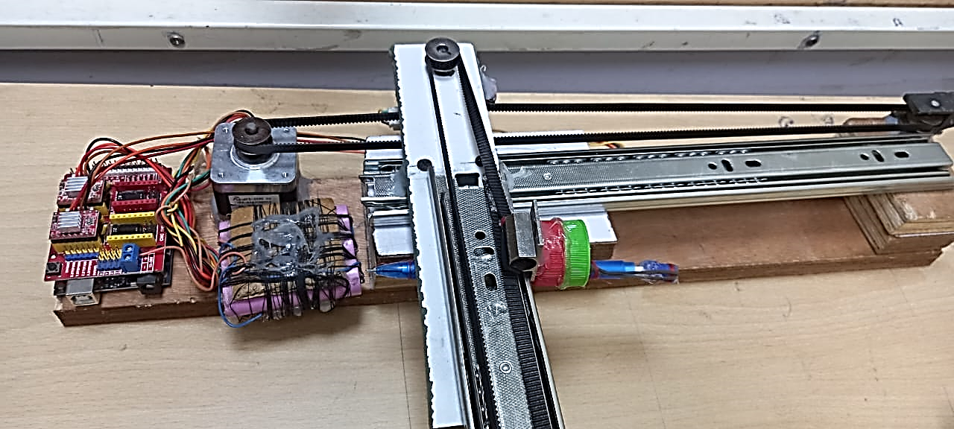
23
Fig. 17 Front view of the project

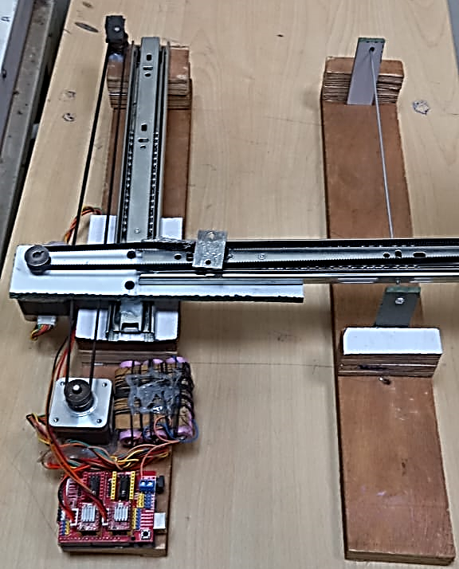
Fig. 18 Side view of the project
- CONCLUSION
24

The Voice-Assisted Graphic Machine project represents a important rise forward in the zone of art creation, introducing a original combination of technology and traditional technique. Through particular analysis and evaluation, several key observations develop, cracking light on the project's strengths and limitations. The Voice-Assisted Graphic Machine project validates significant ability in revolutionizing the art-making process through innovation and automation. While it shines in accuracy, speed, and flexibility, addressing limitations in drawing area, handling complex designs, and pen pressure control will be critical to solving its full possible with continued modification and development, the project has the likely to redefine the limitations of creativity and allow users to set free their artistic visions with accuracy and precision.
  - Observations
The project will be evaluated based on the following criteria:
- Accuracy: The project determines outstanding accuracy and precision in its execution. By using technologies, the machine achieves consistently high-quality results, meeting the severe values of creative quality. This ensures that artworks produced by the machine are correct to the user's vision.

- Speed: One of the project's standout features is its impressive speed capabilities. With the ability to operate at frame rates ranging from 100 to 5000, the machine offers unparalleled efficiency in art production. This rapid pace not only enhances productivity but also allows for the creation of complex artworks within compressed timeframes, empowering users to explore and experiment with their creativity without constraints.

- Flexibility: The flexibility of the Voice-Assisted Graphic Machine is another key highlight. Designed to perform a variety of tasks, including drawing and writing, the machine offers users a wide range of creative possibilities. Its flexibility ensures that it can easily put up different creative preferences and requirements of users across various domains.

  - Limitations
25
The project limitations are:
- Drawing Area Limitations: Despite its impressive capabilities, the project is controlled by limitations in the drawing area due to the motor's travel range. This may challenges occur when working on larger-scale artworks or compositions that beat the machine's 3-D limitations. Addressing this limitation would require innovative solutions to enhance the machine's reach and handling.

- Handling Complex Designs: Another limitation of the project lies in its difficulty in handling complex designs with protecting details. While the machine shines in executing precise lines and methods, it may struggle with difficult shading techniques that require control the complexity. Overcoming this limitation would require developments in the machine's algorithms and physical abilities to accurately understand.

- Pen Pressure Control: Achieving perfect pen pressure control remains an ongoing challenge for the project. While the machine is capable of producing consistent results, achieving dynamic variations in pen pressure to compete with natural hand movements presents a significant difficulty. Enhancing pen pressure control would require further change of the machine's hardware and software components to do the improvements of traditional drawing techniques.
- FUTURE SCOPE
26

The project has to improvements and future developments for the machine:
- The machine continues to cover the way for innovative art creation, its future holds exciting opportunities for further improvements and developments. Building upon its existing foundation, the project's future scope includes two key areas:
    - Upgrading the machine's frame motors for a larger drawing area.
    - Implementing additional functionalities such as pen color changing mechanisms.

- One of the primary objectives for future enhancements involves upgrading the machine's frame and motors to put up a larger drawing area. Currently, the machine offers a specific picture size for creating artworks. By enhancing its structural components and motor capabilities, the machine can extend its reach, allowing users to produce larger and more expansive artworks.

- In addition to expanding the drawing area, future developments for the Voice-Assisted Graphic Machine include implementing additional functionalities, such as pen color changing mechanisms. Currently, the machine may be limited to utilizing a single pen color for its artworks.

- The future improvements carry important inferences for the Voice-Assisted Graphic Machine and its users. By upgrading the machine's frame and motors for a larger drawing area, creators gain increased flexibility and freedom to explore their artistic visions on a larger scale. These developments raise the Voice-Assisted Graphic Machine to new heights of innovation, allowing artists to release their full creative potential with ease and precision.
REFERENCES
27

- Kywe, Thiri, Hnin Ngwe Yee Pwint, and Thae Thae Ei Aung. "ARDUINO BASED AUTOMATIC MINI CNC MACHINE FOR DRAWING." International Journal Of All Research Writings 2.3 (2019): 51-58.
- Bowen, James. "Voice as a tool for drawing." PhD diss., Loughborough University, 2023.
- Pawar, A. S., Halunde, M. J., Nayakawadi, S. M., & Mirajkar, M. P. (3). Axis Drawing Machine. International Research Journal of Engineering and Technology (IRJET), 4(3), 693-697.
- Megalingam, Rajesh Kannan, Shreerajesh Raagul, Sonu Dileep, Sarveswara Reddy Sathi, Bhanu Teja Pula, Souraj Vishnu, Vishnu Sasikumar, and Uppala Sai Chaitanya Gupta. "Design, implementation and analysis of a low cost drawing bot for educational purpose." International journal of pure and applied mathematics 118, no. 16 (2018): 213-230.
- Arduino, Store Arduino. "Arduino." Arduino LLC 372 (2015).
- Van de Straete, Herman J., Pascal Degezelle, Joris De Schutter, and Ronnie JM Belmans. "Servo motor selection criterion for mechatronic applications." IEEE/ASME Transactions on mechatronics 3, no. 1 (1998): 43-50.
- Fa-Qun, Qi, Jing Xue-Dong, and Zhao Shi-qing. "Design of stepping motor control system based on AT89C51 microcontroller." Procedia Engineering 15 (2011): 2276-2280.
- Arduino uno - https://docs.arduino.cc/hardware/uno-rev3/ Last accessed 3/4/2024
- CNC Shield - https://shorturl.at/FR048 Last accessed 3/4/2024
- Stepper motor -https://en.wikipedia.org/wiki/Stepper_motor Last accessed 3/4/2024
- Servo motor - https://en.wikipedia.org/wiki/Servomotor Last accessed 3/4/2024
- A988 Stepper motor driver - https://www.pololu.com/product/1182 Last accessed 3/4/2024
- Jumper wire - https://blog.sparkfuneducation.com/what-is-jumper-wire Last accessed 3/4/2024
- Belt & pulley - https://sites.google.com/site/designoftransmissionsystems/Design-of-Flexible-Elements/belts Last accessed 3/4/2024

